MACH4METAL

metalworking machinery
Transito 21
6909 DA BABBERICH Netherlands
Tel. +31 (0)316-247123
Fax: +31 (0)316-247956
info@mach4metal.com
www.mach4metal.com

Bank No : 66.52.13.883
IBAN : NL33 INGB 0665 2138 83
BIC : INGBNL2A

Beyeler Pressbrake 3100 x 300 T
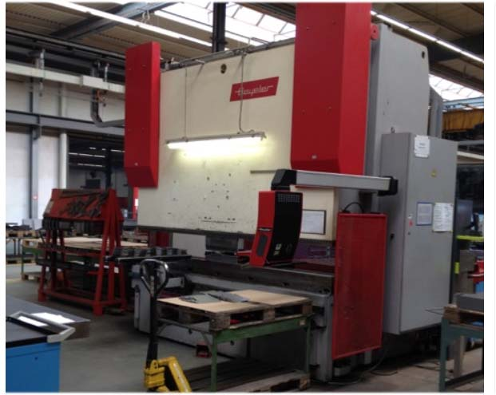
- Make : BEYELER Swiss
- Typ : PR 6
- Mach.No : 1071 003
- Yop : 2000

- Max. bending length : 3.100 mm
- Between column : 2.600 mm
- Max. Force : 300 ton

- Dis. Beam - Table : 1.100 mm
- Stroke : 315 mm
- Throath : 400 mm
- Table width : mm
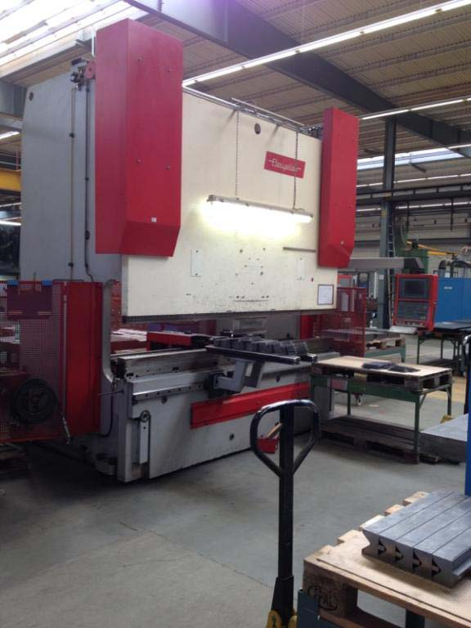

- Approch speed : 200 mm/min.
- Working speed : 10 mm/min.
- Return speed : 100 mm/min.

- Cybelec DNC 1200 in 6 axis
- Y1 / Y2 / X / R / Z1 / Z2

- Dimensions
- Length : 4.000
- Width : 2.300
- Height : 3.500
- Table height: 830
- Weight : 23.000 Kg
- Power kW : 20 kW

- Hydraulic operated
- Clamp system

Please Note: The above information has been obtained to the best of our ability and belief from, and from the manufacturers where possible. It is given in good faith, but its accuracy can not be guaranteed. Accordingly, it will not form a representation or constitute contractual terms. We advise you to check any vital details!

